Project Executable Files

Date | 2 july 2026
Team ID | xxxxxx
Project Name | xxxxxx
Maximum Marks | 3 Marks

Project Executable Files
This section requires submission of all executable and deployable files for your project. Ensure all files are properly organized, named, and uploaded to the specified submission platform. The evaluator must be able to run or deploy your solution using the provided files and instructions.

Step 1: Submission Checklist

S.No | Item to Submit | Submitted (Yes / No / NA)
1 | Complete source code (all files and folders) | yes
2 | README / Setup Guide (instructions to run the project) | yes
3 | requirements.txt / package.json / dependency file | yes
4 | Database schema / seed files (if applicable) | NA (if you used only a CSV dataset)
5 | Environment configuration file (.env.example or similar) | No (or Yes, if used)
6 | Deployed application URL (if hosted) | No (or Yes, if deployed on IBM Cloud)
7 | APK / Executable binary (if applicable for mobile/desktop apps) | NA (Web application)
8 | Dockerfile / Containerization config (if applicable) | No (unless you created one)
9 | Test files and test results | Yes

Step 2: File / Folder Structure
Provide an overview of your project's file and folder structure below:
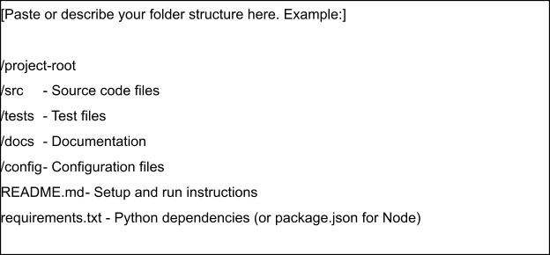

Step 3: Deployment / Access Details

Field | Details
Hosted / Deployed URL | IBM Cloud URL (if deployed) or Not Deployed
Login Credentials (Demo) | Not Required (if your application does not have a login page)
Platform / Hosting Provider | IBM Cloud (or Local Flask Server if not deployed)
Repository Link | https://github.com/rajkumar0611
Demo Video Link

Step 4: Run Instructions
Provide clear, step-by-step instructions for the evaluator to run your project locally:
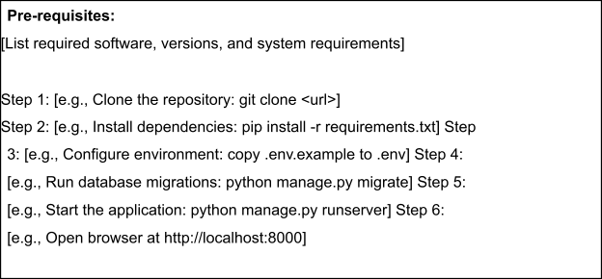

Step 5: Known Issues / Limitations

S.No | Known Issue / Limitation | Workaround / Status
1
2
3

